Echo Shift
Project Mid-Term Update
COSC 3026 (Game Design)
Instructor: Dr. Ratvinder Grewal
Group Members:
Abu Ishaque Md Israil #0449749
Chowdhury Shafquat Ahmed Nibraj #0442248
Nahidul Islam Emon #
Suraz Mohammad #0441075
Anik #
27th October, 2026

Project Overview
Echo Shift is a solo, top-down, turn-based game that utilizes a pre-recorded echo to solve spatial puzzles regarding power allocation. Currently, the midterm version of Echo Shift consists of three chambers to play in. Each chamber introduces a corresponding rule: walking on lighted tiles is safe, picking up circuits is subject to a power cap, and using echo to keep passive pads powered while moving across a gate. The goal of each chamber is for the player to get to the elevator when it is operational. The game was designed and built on Windows 11 using Python and Pyxel.
The design challenge was to design a small set of rules that can be understood, while the player can think about their current and future actions. Powering a corridor makes it safe without operating the machine, since the linked pad may not be active. An occupied pad may operate the trigger of the machine, yet the machine itself stays idle, as there is no power on its circuit. The player needs to balance his/her choices of circuits, timing of turns and pads' occupancy. In the third chamber, one body can neither occupy the pad nor walk through the gate simultaneously, which makes the use of the recording system inevitable.
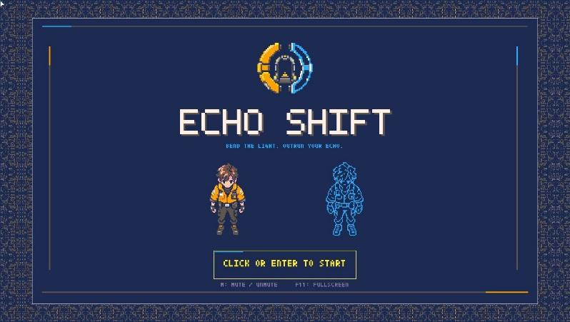
The midterm scope is deliberately limited. This scope shows the basic mechanics of the game, local progress save, tutorials, optional hints, and retry and pause functionality. The final version of the game is supposed to consist of six chambers; however, the later three are not included in this build. The midterm evaluation would rely on deterministic automated tests.
Figure 1: The refreshed title screen and approved character pair.

Player Experience and Controls
The title screen takes you to the chamber selection screen. The player starts from chamber 1; completion of chamber 1 unlocks chamber 2, and the completion of chamber 2 unlocks chamber 3. Each chamber starts with the dismissible tutorial. The tutorial can be shown again using T, and hints can be shown using H. Hints are logged in the playtest record in order to differentiate between the independent and hint-dependent solution in future feedback.
Movement is controlled by the WASD or arrow keys. E opens the console if the player is standing on its hub tile. In the console, Up and Down keys select the circuit, Space toggles it, and Enter confirms the selection. If the selection is above the capacity, it is refused and the warning message appears. Enter starts and applies the recording; Space waits; Q starts the echo. R resets the playback snapshot and C clears the chamber and its recording. P pauses the game, L switches back to chamber selection, and M toggles the mute on the game. Menus and pauses don't count turns.
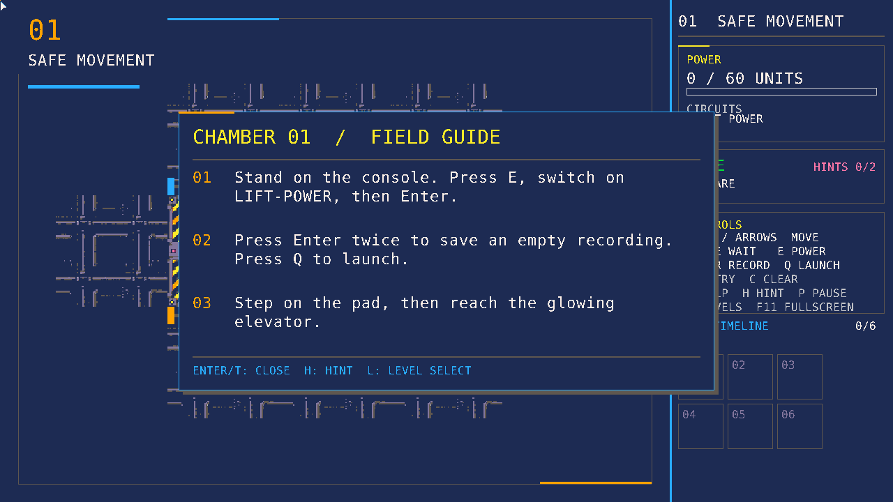
Game starts in the window with up to 1280 × 720 size that is shrunk to fit the desktop if needed. F11 and Alt+Enter switch to fullscreen mode. At the 1536 × 864 reference resolution, the room has the 1152 × 864 sized area on the left side and the 384-pixel-wide status panel on the right side. Short routes are fitted with their traversable tiles plus a wall border around them so that empty large wall areas don't obscure the puzzle. Underlying 12 × 9 grid stays the same. Panel shows the current power load, safety status, circuits, feedback, hints, controls and available recording slots in this chamber. Console shows a preview of the zones which will be darkened before applying the selection. Bundled font allows keeping the explanations legible as the window is resized.
Figure 2: Dismissible chamber instructions

Rules and Turn Timing
It is always safe inside the hub and contains the console. When the player ends their turn on an unlit tile outside the hub, the attempt fails. The power capacity of the pad is an allocation limit applied simultaneously and not depleted by turns. Acceptable moves, waits and interaction with the console are actions of advancing the game. An unsuccessful movement into a wall or closed gate doesn't advance the game. It is important that any invalid action shouldn't advance the echo or a timer.
Every accepted turn includes one order. First, it removes an expired echo and restores the state of pads and devices. Second, the power change is made. Third, a player and echo move according to the available gate state. Fourth, a pad occupancy and a counter of timed-pads are updated, setting the device states for the next turn. Fifth, player safety and exit from the elevator are checked. Following this sequence in one function makes timing of events in every chamber consistent.
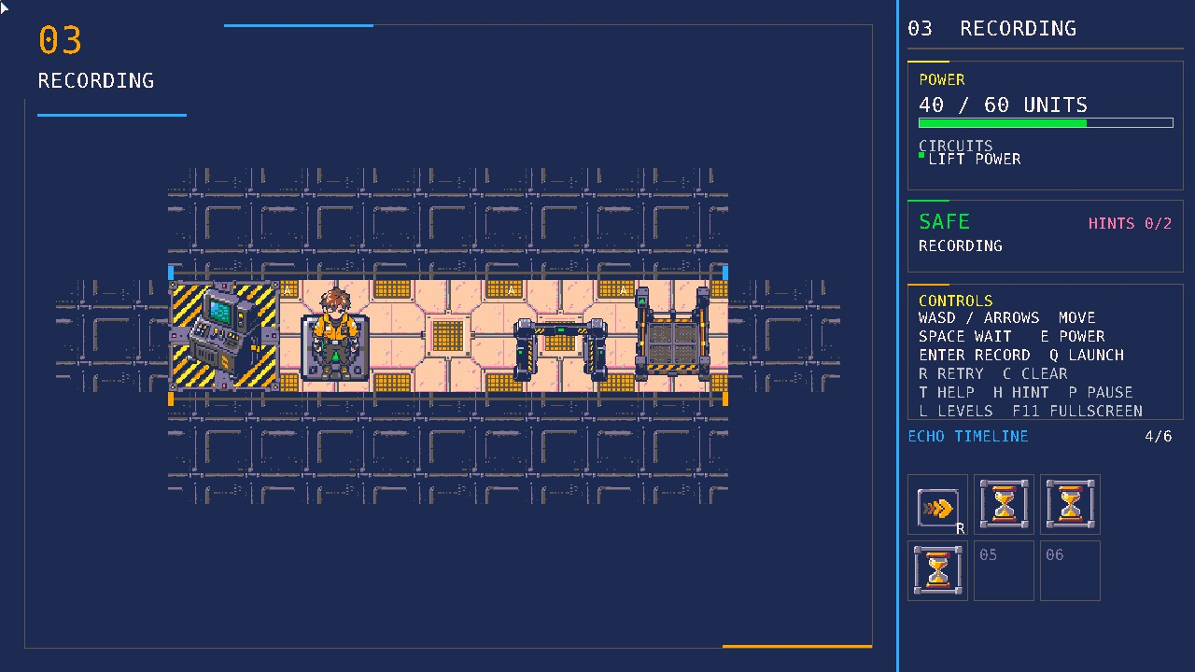
The recording saves all accepted moves and waits. At the game launch, the dynamic chamber state is reset, the player goes back to the starting point, an unadvanced echo is created for the recording start tile and a snapshot of retry is captured. The echo uses command *k* in the replay turn *k*. A blocked echo command consumes the move without movement. At the end of commands, the echo survives for a hold turn and then expires. It gives time for the last tile pad to keep the gate open for the player crossing. The echo can overlap the player but doesn't provide power to the circuit.
Figure 3: Four accepted actions stored in the echo timeline.

Three-chamber Learning Sequence
Chamber 1 presents the player with a short path, one pad and one elevator. It revolves around standing at the console, enabling the lift circuit, starting a recording and watching the pad operate the elevator. Its timed pad stays active for some time even after the player moves away from it, so that the player can reach the elevator without recording an effective echo. This allows the first puzzle to be centered on the understanding of basic mechanics and the relation between pad and elevator.
Chamber 2 adds several circuits and a 60-unit capacity. Path lights take 20 units, lift power takes 35 and the auxiliary circuit takes 15 units. The effective combination costs 55 units. Enabling all three would take 70 units, so the console won't accept it. This chamber tells the player about the limitation being valid for the current choice and that lighting a path and powering an elevator are two separate things. An additional circuit allows the player to try a seemingly sensible but useless choice.
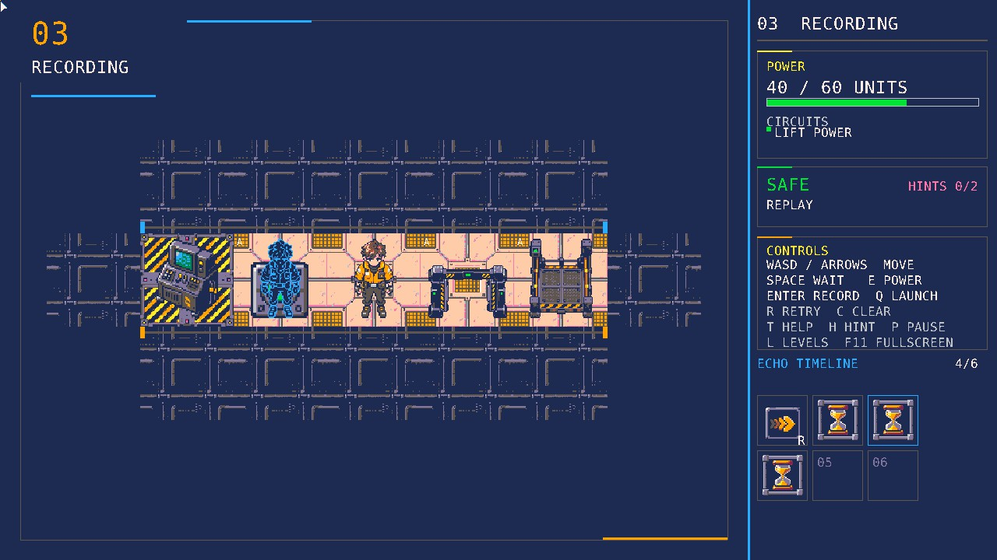
Chamber 3 presents a passive pad connected to a gate and an elevator. The cost of the only lift circuit in the chamber is 40 units. The pad becomes active as long as there is a body in it. In case the player leaves the pad unattended, the gate closes before he can pass through. Recording the sequence Right + Wait*3 provides enough time to remain on the pad while the player is moving from the pad to the gate and elevator. This chamber aims to force replay through layout and timing and not with a special chamber rule.
Figure 4: The echo holds pad A while the player crosses the gate.
All three chambers use JSON files. The engine loader checks positions, connections, IDs, capacities and command limitations. The same engine will interpret all three chambers, so future tuning will allow us to change the cost of commands and their descriptions without changing the puzzle logic.

Implementation Structure
The separation of deterministic rules from graphics and input means that engine/ package has no Pyxel imports. The engine contains the model of the chamber and state; the loader converts validated JSON to the chamber; power and lighting functions compute the circuit allocation and safe tiles; the recording functionality is for preparing, recording, committing, and replay states; and the turn module computes the five ordered steps. In this way, the code of the rules can be run in automated tests without opening a window.
The ui/ package provides Pyxel input, graphics, menus, HUD, sprite lookup, progress and playtest telemetry. The art assets are preloaded using the generated atlas, so that game code references sprite IDs but not the coordinates of images in the renderer. The tiles are automatically dimmed using the palette remap at draw time, so the separate dark sprite files are not required. The game loads JSON and atlas files relative to the entry point of the application; progress and log files are saved into the user directory, so there is no attempt to write somewhere near a packed Windows executable.
The local progress file holds only the highest unlocked chamber. The playtest file is a JSONL file where each line corresponds to one visit of the chamber with a random attempt identifier, chamber number, completion status, elapsed time, reset and hint counts and confirmation of over-budget use. Movement traces, names and other personal information are not stored there. The path to the collection is known using moderator protocol; player-facing overlays do not contain any filesystem paths. The unfinished attempt is written on quitting the game; going back to the level selection screen does the same thing. Pause time is included in the elapsed time.

Art Direction and Readability
The visual system operates using the fixed PICO-8 16-colour palette. Black is the transparency key. The player is an amber technician, and the echo uses the identical silhouette with a blue contour and dark hollow inside. Matching silhouettes show that the echo is an echo of the player, and different outlines create distinguishable bodies on the same tile.
Tiles, machines and timeline use 96 × 96 assets. Sprites are generated, colour processed to the palette, verified for 96 pixels in dimension and binary alpha, and packed to an atlas. Native-size contact sheets and repeated tile previews are used for legibility and seam verification. Darkness applies a fixed remap when drawing instead of erasing geometry: the dark tile will be visible enough for planning routes. The power console previews which zones will be dark before making a decision. The HUD also marks the safety as either SAFE or DARK, so that the player does not have to distinguish the tiles by colour only.
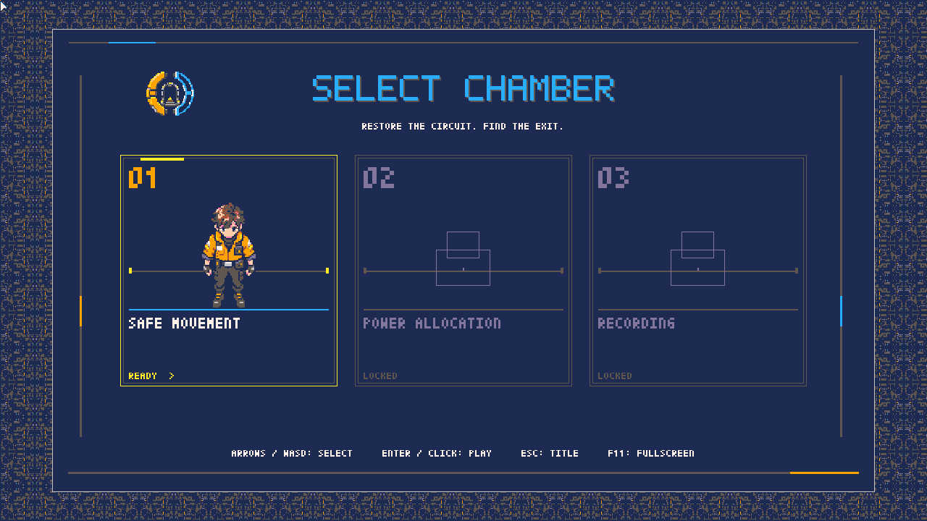
The player and echo visual design is already approved by the users. The display refresh reprocesses the preserved raw assets rather than upscaling old outputs. The title screen and selection screens feature a validated industrial background, power gate emblem, clickable chamber cards and a themed pointer. As of 2026-10-01, the real window fullscreen captures were reviewed under Manjaro. They provide evidence of local rendering. It does not provide the evidence of Windows DPI scaling, pointer and packaged resources behaviour. Round 1 tests should verify whether new players can recognize the active pad, powered circuit and active machine quickly. In case of confusion about an occupied pad for the powered machine, the most impactful solution might be either wording or a small indicator change, but not additional artwork. Any changes to the visual cue must be observed and any new art must be validated.
Figure 5: Clickable chamber cards retain the learning sequence.

Verification Completed
The project has automated test coverage of grid motion, power budget rejection, lighting, turn order, pad timers, recording and retry semantics. Solution traces replay the entire three chambers in the real engine and verify success. The third chamber has an exhaustive no-echo search over all reachable relevant engine states, using the real turn transition as opposed to some simulation thereof. The search ends when all states are explored, and a search cap would render the proof inconclusive rather than a success. This indicates the necessity of an echo in the third layout.
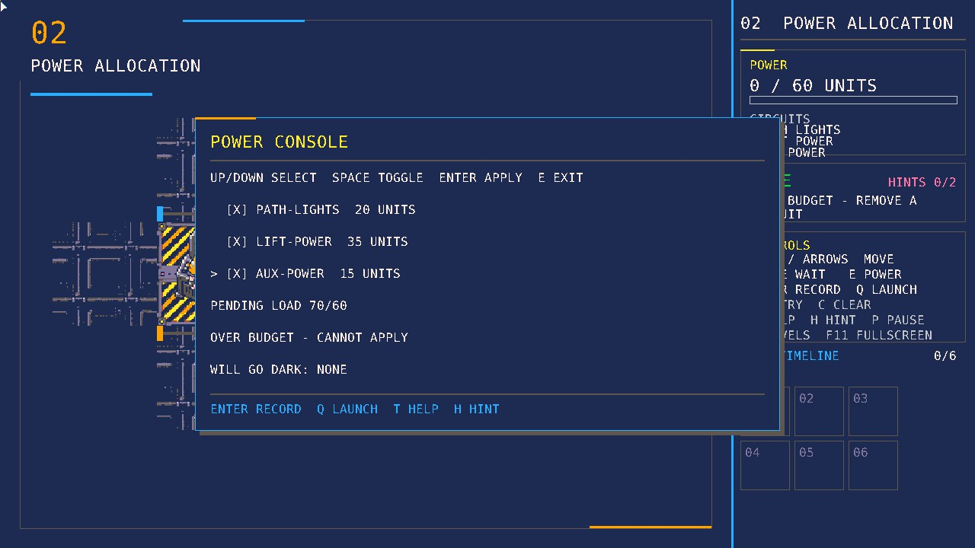
The UI tests drive the Pyxel game logic with input sequences to verify the level selection, locks and unlocks, tutorials, hints, pause, restart and telemetry. The asset validation checks sprite formatting, palette membership and alpha value correctness. These serve to discover logic and data regressions but do not substitute for the manual visual validation and the Windows executable run. An earlier prototype was packaged and run under Windows from some completely unrelated working directory. The current telemetry build still needs packaging under Windows and then a fresh manual validation before claiming the midterm milestone.
Figure 6: A 70/60 selection is refused by the current console.

Midterm status and next steps
The three chamber design exemplifies the expected rules and learning progression. The code isolates puzzle rules from Pyxel, separates level data from engine code, and stores player-generated files externally from the packaged game. The automatic solver trace and no echo proof constitute concrete evidence about the puzzles. The other midterm evidence consists of three to five new sessions of playtesting, their returned logs and observations, a revised report based on those results, a demo recording of 3-6 minutes, and the current Windows executable running from a separate directory.
The next phase of development includes chambers 4-6 after meeting the midterm milestone. These chambers may use the systems that have been built in novel arrangements. Round one results should provide guidance for explanation and difficulty without introducing new mechanics. Audio and balancing can then be evaluated according to player behaviour. In addition, better movement animation of the characters will be implemented for a better player experience from a graphical perspective. The final release requires another run of the Windows game through all six chambers.

